

**PAABAN PANDA**

**ELECTRICAL ENGGINEERING**

**Overview**

**Problem Statement**

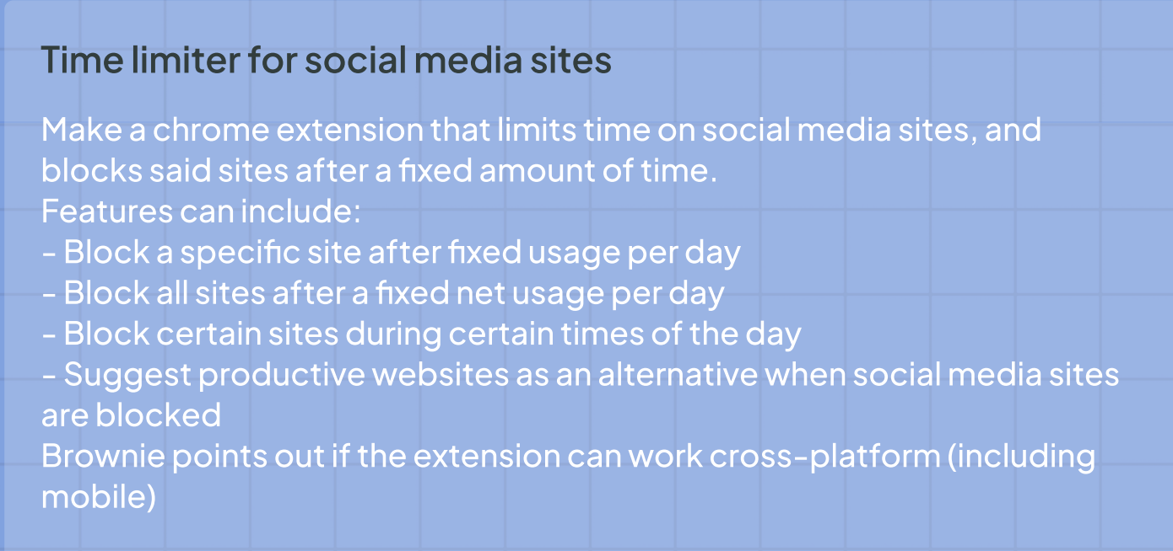

**Impact**

**This chrome extension restrains the user from overusing any social websites by giving an alert after using the social site for a specific duration of time. It also blocks the websites during a period of day.**

**Detailed Solution**

**The extension has the following features:-**

1. **Blocks the website after fixed usage per day.**

**After using any social site for 10 minutes it closes the site by showing a page like this:-**

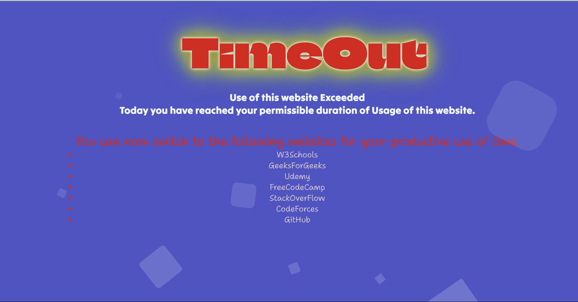

**Background credits- https://alvarotrigo.com/blog/animated-backgrounds-css/**

**JS Code for limiting the use:-**

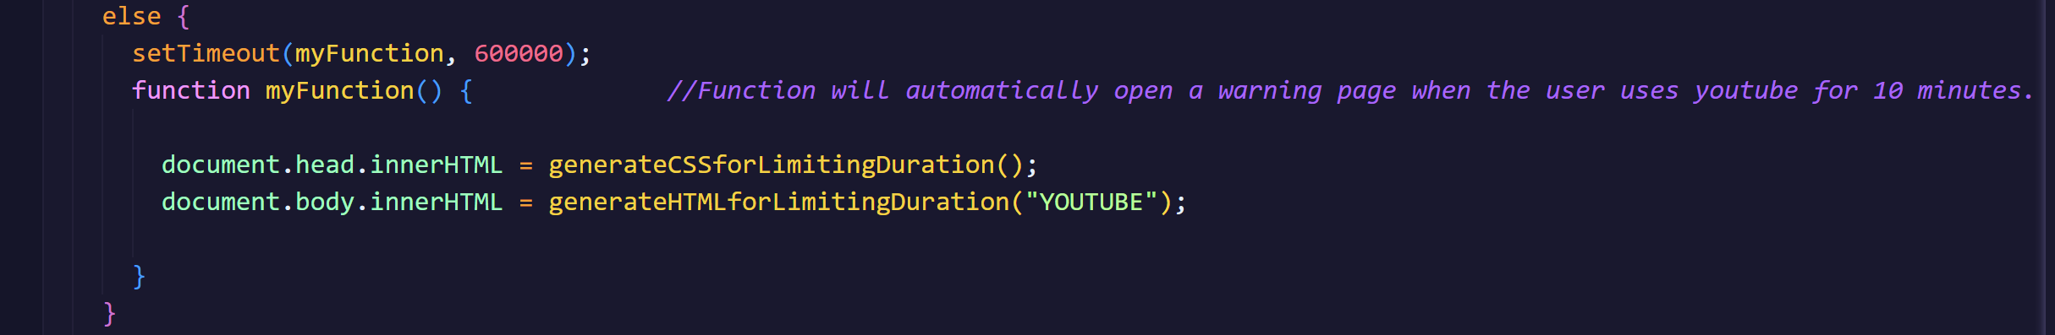

**generateCSSforLimitingDuration() function gives the CSS behind the page and generateHTMLforLimitingDuration() function gives the HTML behind the page as defined above in code.**

1. **Suggest some useful websites after the time limit exceeds.**

Following suggestions are made after sites being blocked.

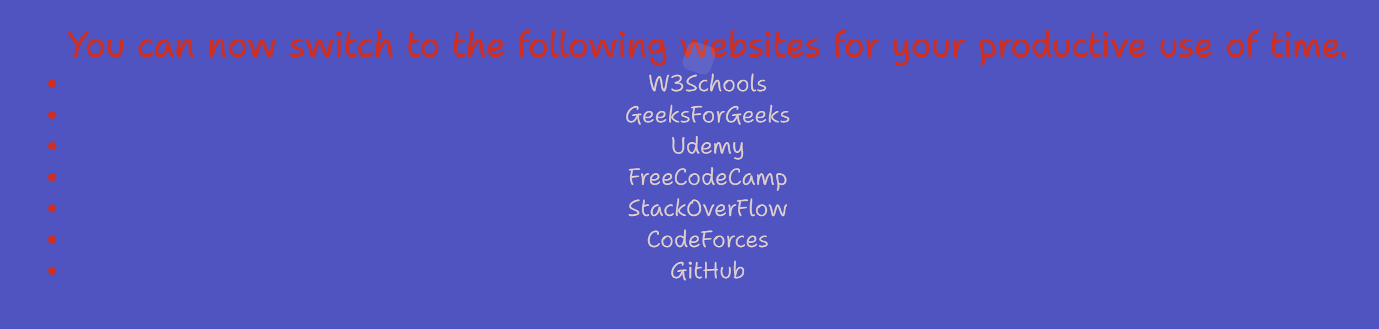

**HTML code for this:**

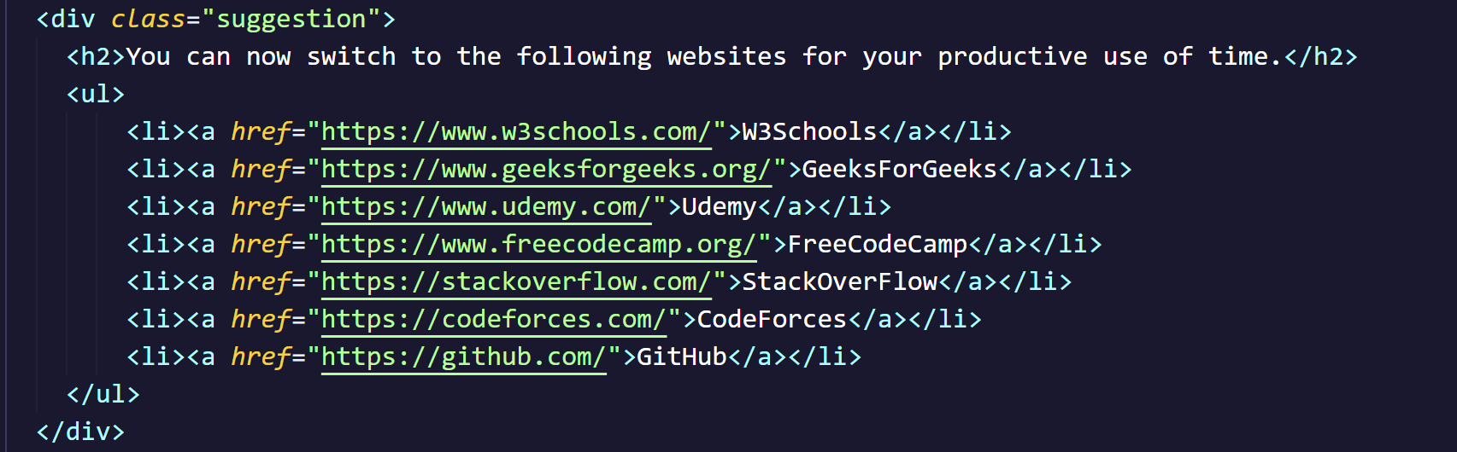

**The user can switch to those after the social websites being blocked.**

1. **Blocks the social sites during some hours of day:**

**If the site is opened during 9AM-4PM then the site can’t be open and a page like this will be shown.**



Backgrounds credits-https://blog.hubspot.com/website/css-animation-examples

**JS code for blocking the page at particular part of day:**



**generateCSSforDeningAccess() function defines the CSS behind this page and generateHTMLforDeningAccess() function creates the basic HTML for the page as defined above.**

**Structure of Extension**

1. **JSON File**

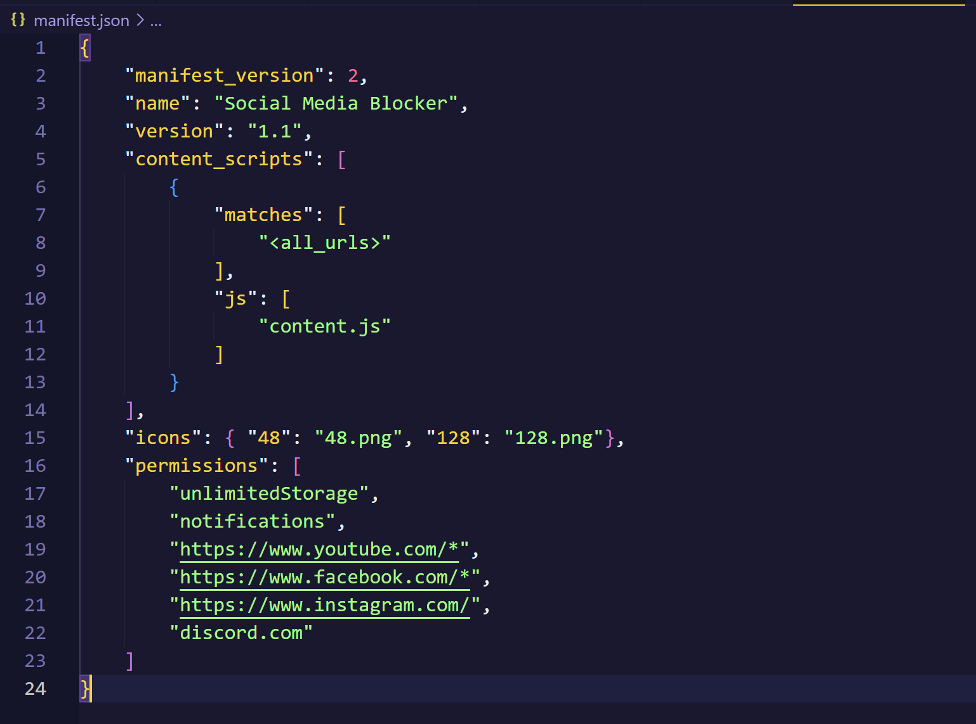

**This manifest.json file controls the extension.**

1. **Extension Button**

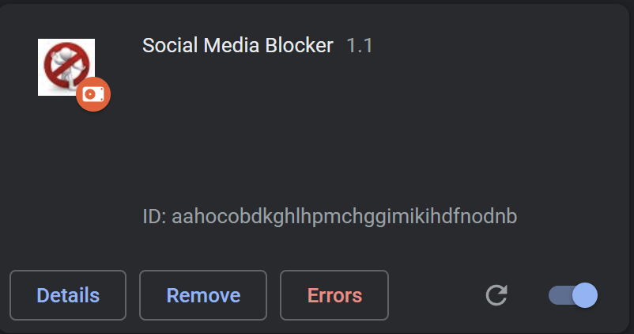

**The extension can be operated from this menu.**

1. **Function that defines HTML and CSS of Pages**

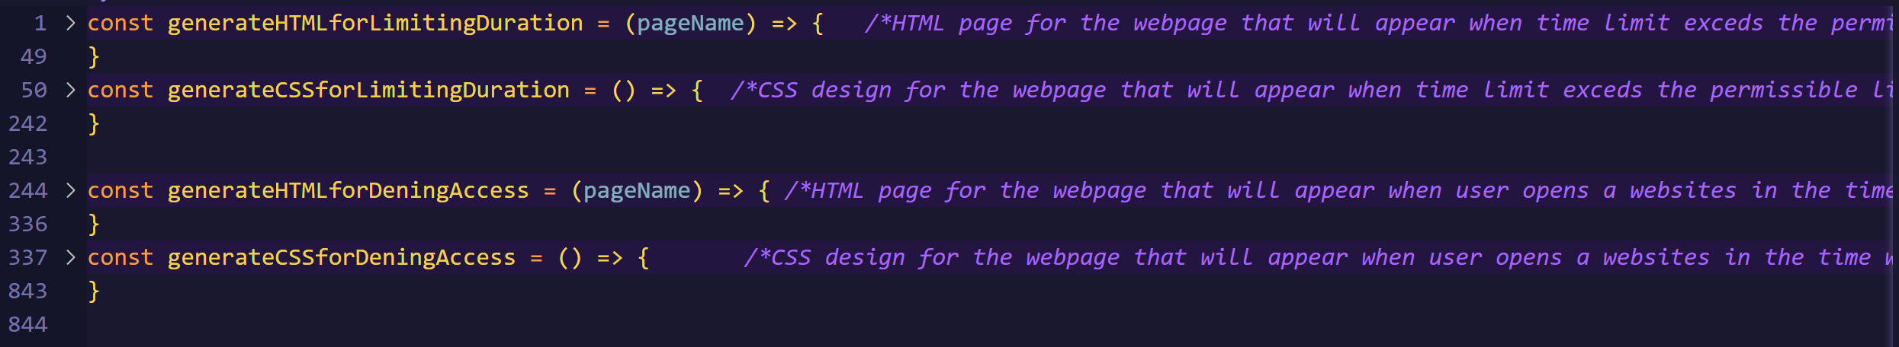

**These 4 functions defined the HTML and CSS for the 2pages.**